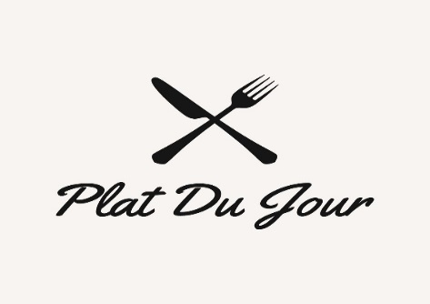

Backyard BBQ/Grill Menu

Smoked St. Louis Ribs - $80half/$160full
Sausage, Peppers & Onions - $75half/$150full
Smoked BBQ or Buffalo Wings - $30 20 pcs/$60 40 pcs
BBQ Pulled Pork Sliders - $75half/$150full
Chili Lime Grilled Shrimp - $85half/$170full
Marinated Grilled Steak Tips $100half/$200full
BBQ Chicken $70half/$140full
Sides:
Cornbread$25 Collard Greens $40
BBQ Baked Beans $50
Coleslaw $30
Mac and Cheese $45
German Potato Salad $50
Pasta Salad $45

www.platdujourcatering.com 781-771-1234

